1.Get me the IP address of a particular domain (guvi.in)

PS C:\Users\user> Ping -4 guvi.in

Pinging guvi.in [104.26.4.88] with 32 bytes of data:

Reply from 104.26.4.88: bytes=32 time=11ms TTL=59

Reply from 104.26.4.88: bytes=32 time=5ms TTL=59

Reply from 104.26.4.88: bytes=32 time=6ms TTL=59

Reply from 104.26.4.88: bytes=32 time=9ms TTL=59

Ping statistics for 104.26.4.88:

Packets: Sent = 4, Received = 4, Lost = 0 (0% loss),

Approximate round trip times in milli-seconds:

Minimum = 5ms, Maximum = 11ms, Average = 7ms

PS C:\Users\user> nslookup guvi.in

Server: UnKnown

Address: fe80::1

Non-authoritative answer:

Name: guvi.in

Addresses: 2606:4700:839a:d255:c1a6:5f6:60b8:c78e

104.26.4.88

172.67.70.207

104.26.5.88

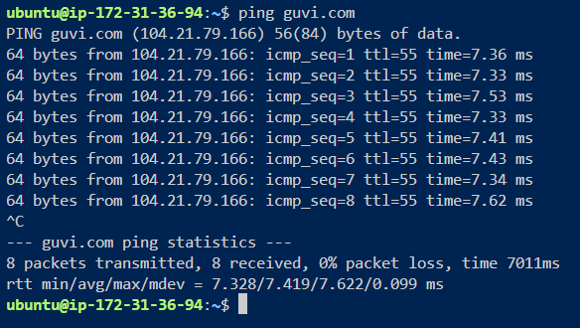

How do I find my CPU/memory usage of my server?.

In AWS portal –

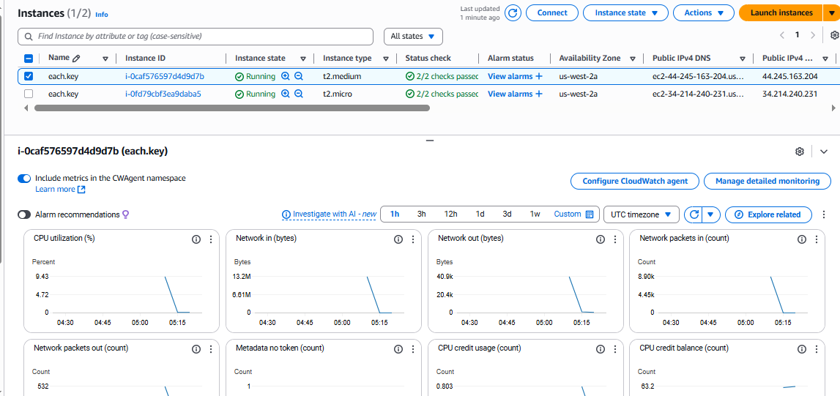

From Linux we use the following command such as top

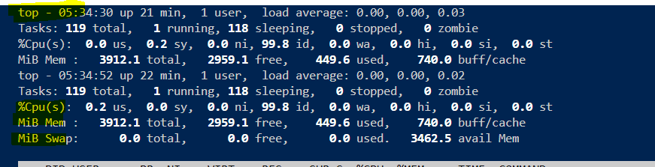

Ping to another machine.

ubuntu@ip-172-31-36-94:~$ uname -a

Linux ip-172-31-36-94 6.14.0-1011-aws #11~24.04.1-Ubuntu SMP Fri Aug 1 02:07:25 UTC 2025 x86_64 x86_64 x86_64 GNU/Linux

ubuntu@ip-172-31-36-94:~$ ip a

1: lo: <LOOPBACK,UP,LOWER_UP> mtu 65536 qdisc noqueue state UNKNOWN group default qlen 1000

link/loopback 00:00:00:00:00:00 brd 00:00:00:00:00:00

inet 127.0.0.1/8 scope host lo

valid_lft forever preferred_lft forever

inet6 ::1/128 scope host noprefixroute

valid_lft forever preferred_lft forever

2: enX0: <BROADCAST,MULTICAST,UP,LOWER_UP> mtu 9001 qdisc mq state UP group default qlen 1000

link/ether 06:88:f2:4e:60:97 brd ff:ff:ff:ff:ff:ff

inet 172.31.36.94/20 metric 100 brd 172.31.47.255 scope global dynamic enX0

valid_lft 2199sec preferred_lft 2199sec

inet6 fe80::488:f2ff:fe4e:6097/64 scope link

valid_lft forever preferred_lft forever

ubuntu@ip-172-31-36-94:~$ ping -c 4 172.31.34.191

PING 172.31.34.191 (172.31.34.191) 56(84) bytes of data.

64 bytes from 172.31.34.191: icmp_seq=1 ttl=64 time=0.568 ms

64 bytes from 172.31.34.191: icmp_seq=2 ttl=64 time=0.596 ms

64 bytes from 172.31.34.191: icmp_seq=3 ttl=64 time=0.515 ms

64 bytes from 172.31.34.191: icmp_seq=4 ttl=64 time=0.628 ms

--- 172.31.34.191 ping statistics ---

4 packets transmitted, 4 received, 0% packet loss, time 3077ms

rtt min/avg/max/mdev = 0.515/0.576/0.628/0.041 ms

ubuntu@ip-172-31-36-94:~$

To check if the nginx ports are listing or not

buntu@ip-172-31-36-94:~$ sudo ss -tulpn | grep nginx

tcp LISTEN 0 511 0.0.0.0:80 0.0.0.0:* users:(("nginx",pid=1619,fd=5),("nginx",pid=1618,fd=5),("nginx",pid=1616,fd=5))

tcp LISTEN 0 511 [::]:80 [::]:* users:(("nginx",pid=1619,fd=6),("nginx",pid=1618,fd=6),("nginx",pid=1616,fd=6))

or alternatively I can use netsh to list all listening ports.